16 January 2012

RESCUE DRIL FOR UNDERGROUND COAL MINES

On 21 January 1960 the roof a large section of the Clydesdale colliery at the Coalbrook Colliery in South caved in and trapped 435 mineworkers 180m underground in the worst mine disaster in South African history. At the time there was an attempt to sink a rescue shaft into the caved area but it was discontinued when it became clear that there were no survivors.

Following this incident, the coal producing members of the Chamber of Mines decided to purchase a suitable drill that would make it possible to reach personnel trapped underground in coal mines. At first a Wirth L10 drill was acquired, but this drill was apparently not suitable for rescue drilling. In 1976 the second rescue drill, an Ingersoll Rand T5 was acquired. It was capable of drilling a 635 mm diameter hole to a depth of 200 m.

During June 1991 a major collapse of ground occurred in the Emaswati Colliery in Swaziland. Twenty-six underground employees of the mine were trapped by the collapse. The rescue drill was brought in from South Africa, a rescue hole was drilled and all the trapped miners were evacuated uninjured. The rescue drill was used again some years later during an underground fire in the Gloria Colliery. In this case a hole was drilled to allow a Rescue Brigade to access the workings.

During 2011 it became clear that the current rescue drill was obsolete. It was also becoming very difficult to source spares. Consequently the Chamber’s coal producing members agreed to purchase a new rescue drill and ancillary equipment, including a pilot drill, a rescue winders, rescue capsules and a new down-hole camera. The total cost of the package amounted to some R65 million.

The new drill, a Schramm T130XD arrived in South Africa during September 2012
and is currently being homologated to South African road specifications.

Attached are photographs of the drill, the rescue winder and the rescue capsules.

DICK KRUGER
DEPUTY HEAD: TECHNO-ECONOMICS
CHAMBER OF MINES OF SOUTH AFRICA
Tel +27 11 498 7275
Fax 086 750 7855
Mobile +27 82 569 4417
E-Mail dkruger@chamberofmines.org.za

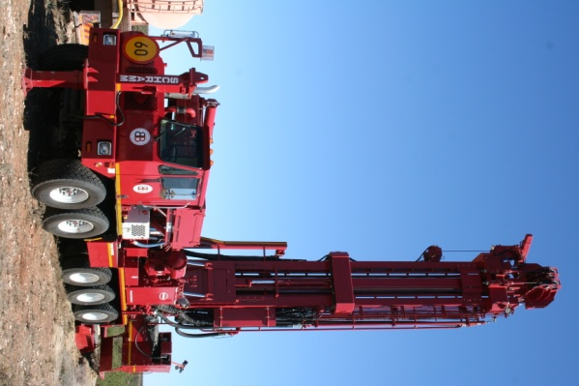
SCHRAMM T130XD RESCUE DRILL
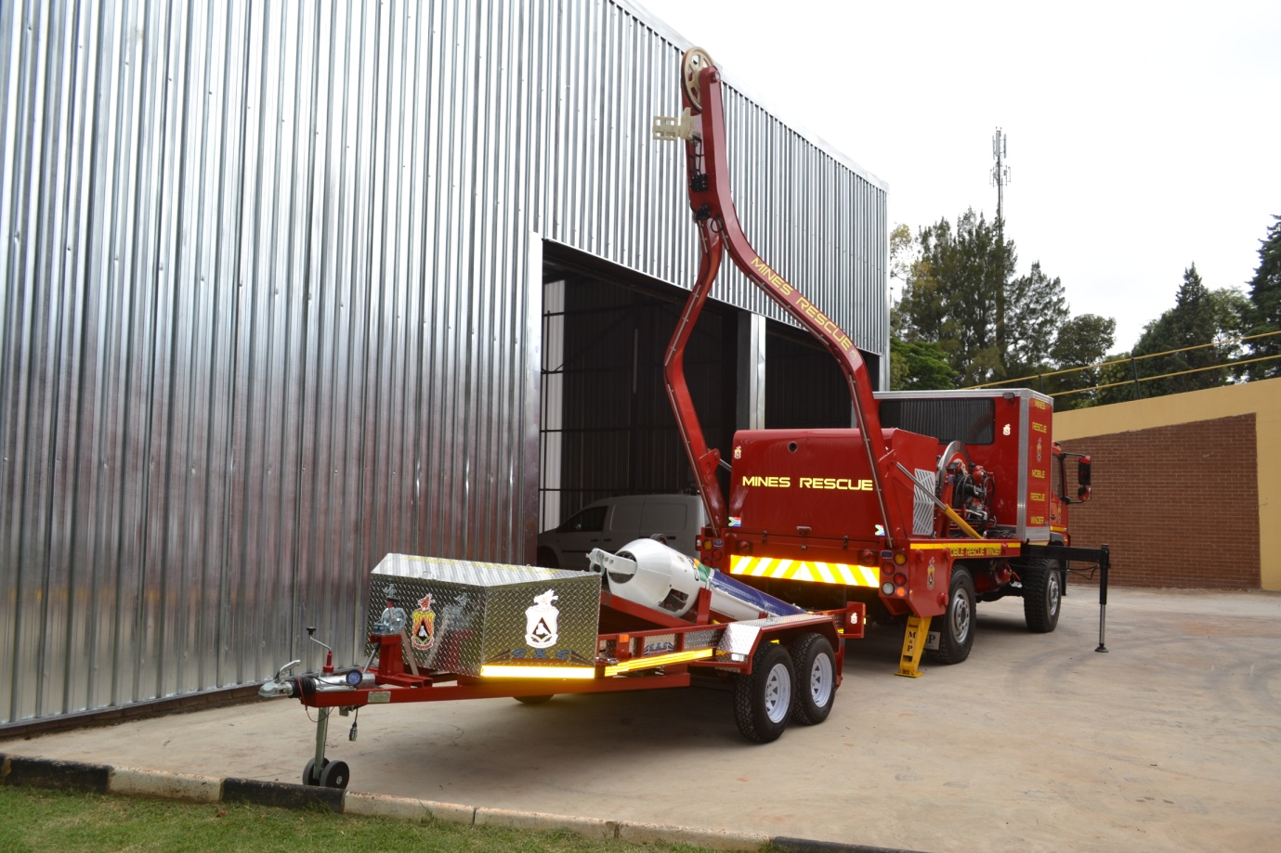

RESCUE WINDER WITH RESCUE CAPSULE ON TRAILER

